**Code for Robert:**

**%Sanika Sandip Firke**

**%Roll No:- 31134**

im=imread('8.tif'); figure(1);

subplot(4,1,1),imshow(im);

title('original image using Robert');

a=double(im);

[rc]=size(a) w1=[10; 0 -1]; w2=[0 1; -1 0]; for x=2:1:r-1;

for y=2:1:c-1;

a1(x,y)=w1(1)*a(x,y)+w1(2)*a(x,y+1)+w1(3)*a(x+1,y)+w1(4)*a(x+1,y+1); a2(x,y)=w2(1)*a(x,y)+w2(2)*a(x,y+1)+w2(3)*a(x+1,y)+w2(4)*a(x+1,y+1);

end;

end;

a3=a1+a2;

subplot(4,1,2),imshow(uint8(a1));

title('x gradient');

subplot(4,1,3),imshow(uint8(a2));

title('y gradient');

subplot(4,1,4),imshow(uint8(a3));

title('resultant image');

**Output:**

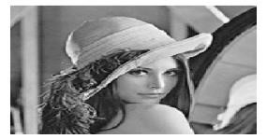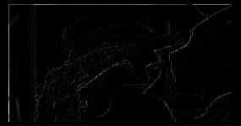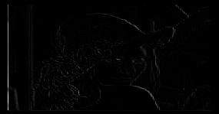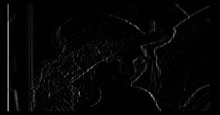

**Code for prewitt:**

**%Sanika Sandip Firke**

**%Roll No:- 31134**

r=imread('8.tif'); r=imresize(r,[256 256]);

figure(2);

subplot(4,1,1);imshow(r);

title('Original image using prewitt'); ss=[zeros(1,256);r;zeros(1,256)]; r1=double([zeros(258,1),ss,zeros(258,1)]);

[z,x]=size(r);

w1=double(([-1 -1 -1;0 0 0;1 1 1]));

w2=w1'; st=1; en=3; st2=1; en2=3; for i=2:1:z+1 for j=2:1:x+1 q=(w1(1,1)*r1(i-1,j-1))+(w1(1,2)*r1(i-1,j))+(w1(1,3)*r1(i-1,j+1)); q=q+(w1(2,1)*r1(i,j-1))+(w1(2,2)*r1(i,j))+(w1(2,3)*r1(i,j+1));

q=q+(w1(3,1)*r1(i+1,j-1))+(w1(3,2)*r1(i+1,j))+(w1(3,3)*r1(i+1,j+1));

sx(i-1,j-1)=q;

q=(w2(1,1)*r1(i-1,j-1))+(w2(1,2)*r1(i-1,j))+(w2(1,3)*r1(i-1,j+1));

q=q+(w2(2,1)*r1(i,j-1))+(w2(2,2)*r1(i,j))+(w2(2,3)*r1(i,j+1));

q=q+(w2(3,1)*r1(i+1,j-1))+(w2(3,2)*r1(i+1,j))+(w2(3,3)*r1(i+1,j+1));

sy(i-1,j-1)=q;

end end subplot(4,1,2));

imshow(uint8(sx));

title('x gradient');

subplot(4,1,3);

imshow(uint8(sy));

title('y gradient');

s=sx+sy;

subplot(4,1,4),imshow(uint8(s));

title('Resultant image');

Output:

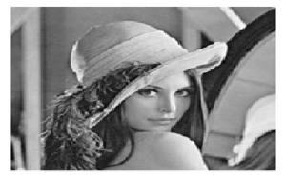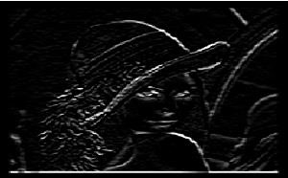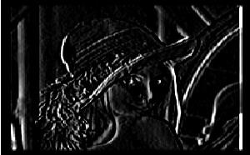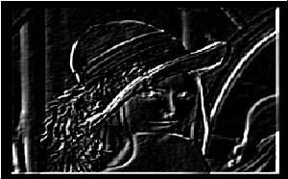

**Code for sobel :**

**%Sanika Sandip Firke**

**%Roll No:- 31134**

r=imread('8.tif'); r=imresize(r,[256 256]);

figure(3);

subplot(4,1,1),imshow(r);title('Original image using sobel');

ss=[zeros(1,256);r;zeros(1,256)]; r1=double([zeros(258,1),ss,zeros(258,1)]);

[z,x]=size(r);

w1=double(([-1 -2 -1;0 0 0;1 2 1]));

w2=w1';

st=1; en=3; st2=1; en2=3;

for

i=2:1:z+1

for j=2:1:x+1

q=(w1(1,1)*r1(i-1,j-1))+(w1(1,2)*r1(i-1,j))+(w1(1,3)*r1(i-1,j+1));

q=q+(w1(2,1)*r1(i,j-1))+(w1(2,2)*r1(i,j))+(w1(2,3)*r1(i,j+1)); q=q+(w1(3,1)*r1(i+1,j-1))+(w1(3,2)*r1(i+1,j))+(w1(3,3)*r1(i+1,j+1));

sx(i-1,j-1)=q;

q=(w2(1,1)*r1(i-1,j-1))+(w2(1,2)*r1(i-1,j))+(w2(1,3)*r1(i-1,j+1));

q=q+(w2(2,1)*r1(i,j-1))+(w2(2,2)*r1(i,j))+(w2(2,3)*r1(i,j+1));

q=q+(w2(3,1)*r1(i+1,j-1))+(w2(3,2)*r1(i+1,j))+(w2(3,3)*r1(i+1,j+1));

sy(i-1,j-1)=q;

end

end

subplot(4,1,2);

imshow(uint8(sx));

title('x gradient ');

subplot(4,1,3);

imshow(uint8(sy));

title('y gradient');

s=sx+sy;

subplot(4,1,4),imshow(uint8(s));

title('Resultant image');

**Output**

